Question 1

You have a simple audio recorder app that lets you capture up to 2-minute audio recordings and save them to the cloud.

Your task is to prepare test cases that will cover core features of the app. The screenshot below contains all possible app states.

Note:

* There are five UI elements: Record, Play, Save buttons; Timer; Status view
* The app works in online and offline modes
* Pressing Record button always starts new recording
* App starts in Idle mode when there's no unsaved data

Answer:

I will make the following assumptions about this app to allow myself to come up with more test cases and define some behaviors to make writing test cases better:

* This app is a mobile app that is available on both iOS and Android platforms.
* This app records from the default microphone endpoint of the device ONLY. Media playback on the device is not looped back into the recorder.
* After the playback is paused, pressing Play again resumes the playback from where it was paused. (By the definition of “Pause”)
  + If the recording is unsaved, when Pause is pressed, the state of the app goes from the 4th screenshot to the 3rd screenshot.
  + If the recording has been saved, when Pause is pressed, the state of the app goes from the 4th screenshot to the 5th screenshot.
  + Since the 4th screenshot is not very clear, assume the timer does not reflect the current playback timestamp. It simply freezes at the length of the unsaved recording throughout the playback.
* The cloud is Google Drive and this app can retrieve the account details stored onboard the device.
* According to this statement “App starts in Idle mode when there's no unsaved data “, assume that if there is an unsaved recording, and the app was forced closed and restarted, the unsaved recording is stored inside the app.
  + The app then starts in the state of the 3rd screenshot instead.
* If a recording was saved before, and the app was forced closed and restarted, the app starts in Idle mode since the statement “App starts in Idle mode when there's no unsaved data” is true. (The data is saved, so there is no unsaved data.)
* If the app is not able to connect to cloud, pressing Save saves to a FIXED local location.
  + The local directory will be the root directory of the device storage, and the file name will be called “recording.wav”.
  + Attempting to save a second time (or save with a “recording.wav” already in the root directory of the device storage) will overwrite the existing “recording.wav” without warning.
* If the app can connect to cloud, the app saves into the root directory of the Cloud folder, and the file name will be “recording.wav”.
  + For simplicity, the app will not save another copy to the local directory.
  + Attempting to save a second time (or save with a “recording.wav” already in the root directory of the Cloud folder) will overwrite the existing “recording.wav” without warning.
* The “Saved!” button is clickable, which does the same thing as “Save”. The save action is carried out without any visual changes to the interface.

In the Expected Results column, the numbering corresponds to the results after executing the corresponding test step.

|  |  |  |  |
| --- | --- | --- | --- |
| Basic Functionality Tests (Internal device mic used) | | | |
| Test | Test Steps | Remarks | Expected Results |
| Record Button  (No previously unsaved recordings) | 1. Press the Record button | Able to start recording, no error or crashes. | 1. The following occurs:  * The timer starts from 00:00.00. * The Record button changes to the Stop button. * The Status View changes from “Idle” to “Recording in Progress”. * Play and Save are still greyed out. |
| Record Button  (There exists a previously unsaved recording) | 1. Press the Record button 2. Press the Stop button 3. Force close the App 4. Re-open the App 5. Press the Record button | Able to start recording, no error or crashes. | 1. The following occurs:  * The timer restarts from 00:00.00. * The Record button changes to the Stop button. * The Status View changes from “Unsaved reocrding” to “Recording in Progress”. * Play and Save are greyed out. |
| Stop Button | 1. Press the Record button 2. Let the recording run for 5 seconds. 3. Press the Stop Button. | Able to stop recording before 2 minutes is up, no error or crashes. | 1. The following occurs:  * The timer stops running. * The Stop button changes to the Record button. * The Status View changes from “Recording in progress” to “Unsaved recording” * Play and Save are no longer greyed out. |
| Auto Stop after 2 minutes | 1. Press the Record button 2. Keep the recording running and don’t do anything. | Able to stop recording on its own after 2 minutes is elapsed, no error or crashes. | 1. When the timer hits 02:00.00, the following occurs:  * The timer stops at 02:00.00. * The Stop button changes to the Record button. * The Status View changes from “Recording in progress” to “Unsaved recording” * Play and Save are no longer greyed out. |
| Play Button (Unsaved recording, Playback NOT previously started) | 1. Press the Record button 2. Let the recording run for 5 seconds. 3. Press the Stop Button. 4. Press the Play Button. 5. Leave the playback running | Able to playback recording, no error or crashes. | 1. The following occurs:  * You can hear the recorded playback accurately. There are no audio artefacts. * The recording is played from the start. * “Play” changes to “Pause” * The Record button and Save are greyed out. * The Status View changes from “Unsaved recording” to “Playback in progress”. * The timer stays at whatever time it showed before pressing Play.  1. The following occurs:  * At the end of the recording, the playback automatically stops. * The Status View changes from “Playback in progress” to “Unsaved recording”. * The “Pause” changes to “Play”. * The Record button and Save are no longer greyed out. |
| Pause Button (Unsaved recording) | 1. Press the Record button 2. Let the recording run for 5 seconds. 3. Press the Stop Button. 4. Press the Play Button. 5. Press the Pause Button. | Able to pause playback, no error or crashes. | 1. The following occurs:  * The timer stays stopped. * The Status View changes from “Playback in progress” to “Unsaved recording”. * The “Pause” changes to “Play”. * The Record button and Save are no longer greyed out. |
| Play Button (Unsaved recording, Playback IS previously started) | 1. Press the Record button 2. Let the recording run for 5 seconds. 3. Press the Stop Button. 4. Press the Play Button. 5. Press the Pause Button after 2 seconds. 6. Press the Play Button again. 7. Leave the playback running | Able to resume playback, no error or crashes. | 1. The following occurs:  * You can hear the recorded playback accurately. There are no audio artefacts. * The recording is played from where it was paused. * “Play” changes to “Pause” * The Record button and Save are greyed out. * The Status View changes from “Unsaved recording” to “Playback in progress”. * The timer stays at whatever time it showed before pressing Play.  1. The following occurs:  * At the end of the recording, the playback automatically stops. * The Status View changes from “Playback in progress” to “Unsaved recording”. * The “Pause” changes to “Play”. * The Record button and Save are no longer greyed out. |
| Save Button (device is online and Cloud account was well set up) | 1. Press the Record button 2. Let the recording run for 5 seconds. 3. Press the Stop Button. 4. Press the Save Button. | Able to save recording, no error or crashes. | 1. The following occurs:  * The Status View changes from “Unsaved recording” to “Recording saved”. * “Save” changes to “Saved!”   Login to Google Drive and check the root directory. The recording should be saved as “recording.wav”. Ensure that the recording is played back correctly. |
| “Saved!” Button (device is online and Cloud account was well set up) | 1. Press the Record button 2. Let the recording run for 5 seconds. 3. Press the Stop Button. 4. Press the Save Button. 5. Wait for at least 1 minute to pass. 6. Press the “Saved!” button | Able to re-save recording, no error or crashes. | 1. Login to Google Drive and check the root directory. The recording should be saved as “recording.wav”. Take note of the timestamp of this file. 2. Login to Google Drive and check the root directory. The recording should be saved as “recording.wav”. The timestamp of this file should be changed. Ensure that the recording is played back correctly. |
| Save Button (device is offline) | 1. Press the Record button 2. Let the recording run for 5 seconds. 3. Press the Stop Button. 4. Press the Save Button. | Able to save recording, no error or crashes. | 1. The following occurs:  * The Status View changes from “Unsaved recording” to “Recording saved”. * “Save” changes to “Saved!”   Check the root directory of the device storage. The recording should be saved as “recording.wav”. Ensure that the recording is played back correctly. |
| “Saved!” Button (device is offline) | 1. Press the Record button 2. Let the recording run for 5 seconds. 3. Press the Stop Button. 4. Press the Save Button. 5. Wait for at least 1 minute to pass. 6. Press the “Saved!” button | Able to re-save recording, no error or crashes. | 1. Check the root directory of the device storage. The recording should been saved as “recording.wav”. Take note of the timestamp of this file. 2. Check the root directory of the device storage. The recording should be saved as “recording.wav”. The timestamp of this file should be changed. Ensure that the recording is played back correctly. |
| Play Button (Saved recording, Playback NOT previously started) | 1. Press the Record button 2. Let the recording run for 5 seconds. 3. Press the Stop Button. 4. Press the Save Button. 5. Press the Play Button. 6. Leave the playback running. | Able to playback recording, no error or crashes. | 1. The following occurs:  * You can hear the recorded playback accurately. There are no audio artefacts. * The recording is played from the start. * “Play” changes to “Pause” * The Record button is greyed out. * The “Saved!” button changes to Save and is greyed out. * The Status View changes from “Recording saved” to “Playback in progress”. * The timer stays at whatever time it showed before pressing Play.  1. The following occurs:  * At the end of the recording, the playback automatically stops. * The Status View changes from “Playback in progress” to “Recording saved”. * The “Pause” changes to “Play”. * The Record button is no longer greyed out. * The Save button is no longer greyed out and changes to “Saved!” |
| Pause Button (Saved recording) | 1. Press the Record button 2. Let the recording run for 5 seconds. 3. Press the Stop Button. 4. Press the Save button. 5. Press the Play Button. 6. Press the Pause Button. | Able to pause playback, no error or crashes. | 1. The following occurs:  * The timer stays stopped. * The Status View changes from “Playback in progress” to “Recording saved”. * The “Pause” changes to “Play”. * The Record button is no longer greyed out. * The Save button is no longer greyed out and changes to “Saved!” |
| Play Button (Saved recording, Playback IS previously started) | 1. Press the Record button 2. Let the recording run for 5 seconds. 3. Press the Stop Button. 4. Press the Save Button. 5. Press the Play Button. 6. Press the Pause Button after 2 seconds. 7. Press the Play Button again. 8. Leave the playback running. | Able to resume playback, no error or crashes. | 1. The following occurs:  * You can hear the recorded playback accurately. There are no audio artefacts. * The recording is played from where it was paused. * “Play” changes to “Pause” * The Record button is greyed out. * The “Saved!” button changes to Save and is greyed out. * The Status View changes from “Recording saved” to “Playback in progress”. * The timer stays at whatever time it showed before pressing Play.  1. The following occurs:  * At the end of the recording, the playback automatically stops. * The Status View changes from “Playback in progress” to “Recording saved”. * The “Pause” changes to “Play”. * The Record button is no longer greyed out. * The Save button is no longer greyed out and changes to “Saved!” |
| Initial App State Tests | | | |
| Initial App State (No previously unsaved recordings / Fresh install) | 1. Fresh Install the App 2. Start the App. | No UI artefacts are observed. | 1. The app starts in the state of the 1st screenshot. |
| Initial App State (There exists a previously unsaved recording) | 1. Fresh Install the App 2. Start the App. 3. Press the Record button 4. Let the recording run for 5 seconds. 5. Press the Stop Button. 6. Force close the App. 7. Re-open the App. | No UI artefacts are observed. | 1. The app starts in the state of the 3rd screenshot. |
| Initial App State (The previous recording was saved) | 1. Fresh Install the App 2. Start the App. 3. Press the Record button 4. Let the recording run for 5 seconds. 5. Press the Stop Button. 6. Press the Save button. 7. Force close the App. 8. Re-open the App. | No UI artefacts are observed. | 1. The app starts in the state of the 1st screenshot. |
| UI Tests | | | |
| Record Button | 1. Start the App. 2. Press the Record button, then press the Stop button. 3. Press the Play button. 4. Press the Pause button. | No UI artefacts are observed on the Record button. | 1. No UI artefacts are observed on the Record button. 2. No UI artefacts are observed on the Record button after pressing the Stop button. 3. The Record button is greyed out, check that no UI artefacts are observed on the greyed-out Record button. 4. The Record button is no longer greyed out, check that no UI artefacts are observed on the Record button. |
| Stop Button | 1. Start the App. 2. Press the Record button. | No UI artefacts are observed on the Stop button after press Record | 1. No UI artefacts are observed on the Stop button. |
| Play Button | 1. Fresh Install and start the App. 2. Press the Record button. 3. Press the Stop button. 4. Press the Play Button and then press the Pause button. 5. Press the Save button. 6. Press the “Saved!” button. | No UI artefacts are observed on the Play button | 1. No UI artefacts are observed on the greyed-out Play button. 2. No UI artefacts are observed on the greyed-out Play button. 3. No UI artefacts are observed on the Play button which is no longer greyed-out. 4. No UI artefacts are observed on the Play button. 5. No UI artefacts are observed on the Play button. 6. No UI artefacts are observed on the Play button. |
| Pause Button | 1. Fresh Install and start the App. 2. Press the Record button, then press the Stop button 5 seconds later. 3. Press the Play Button. | No UI artefacts are observed on the Pause button | 1. No UI artefacts are observed on the Pause button. |
| Save Button | 1. Fresh Install and start the App. 2. Press the Record button. 3. Press the Stop button. 4. Press the Play Button and then press the Pause button. | No UI artefacts are observed on the Save button | 1. No UI artefacts are observed on the greyed-out Save button. 2. No UI artefacts are observed on the greyed-out Save button. 3. No UI artefacts are observed on the Save button which is no longer greyed-out. 4. No UI artefacts are observed on the Save button. |
| “Saved!” Button | 1. Fresh Install and start the App. 2. Press the Record button. 3. Press the Stop button. 4. Press the Save button. 5. Press the “Saved!” button. | No UI artefacts are observed on the “Saved!” button | 1. No UI artefacts are observed on the “Saved!” button. 2. No UI artefacts are observed on the “Saved!” button. |

Here are some additional test cases that can be considered:

* Recording with Low Power Mode (iOS) or Battery Saver Mode (Android)
* Recording with an earphone plugged into the device’s jack (3.5mm/USB)
* Recording with a Bluetooth headset
* Start recording with the device’s internal mic, but connect a Bluetooth headset halfway through the recording (Ensure the recording doesn’t cut off halfway, but transfers to the Bluetooth headset)
* Stress start and stop the recording
* Stress play and pause the recorded recording
* Minimize the app while recording
* Stress Minimize and maximize the app while recording
* Force close the app while recording (No crash)
* Force close the app while playing the recorded recording (No crash)
* Force close the app just after pressing Save when device is online (No crash)
* Playback media in another app and press Record (Make sure the media in other app is not cleanly recorded in the recording – this will usually be some feedback loop into the device mic)
* Performance Test for recording: start and stop recording a few times and check CPU usage
* Performance Test for recording playback: start and stop playback a few times and check CPU usage
* Performance Test for saving: save recording a few times and check CPU usage

Question 2

Create a bandlab login and using the ios or android app or the web version of BandLab create a short song (no longer than 2min)

Please note, you are NOT being assessed on the quality of your song! You do not need to spend a long amount of time making this song, it does not even need to be a completed song. Just try to use some of the different features and options in the app. You do not need to be an experienced musician or producer to complete this task. It is more important to us to get your feedback on your experiences while using the product. If you are inexperienced using DAWs please share any challenge big or small.

Please share a writeup below on:

* Challenges you faced UX issues or features that didn’t work how you like and how you would prefer them to work
* Any bugs you came across
* Features of the app you enjoyed
* Your general approach to making the song
* Any general comments or feedback on the BandLab app Please also share a link to your song

Answer:

Note: I used the web version of BandLab to create my song. I also briefly looked through the mobile’s interface.

Please find my link to “thelvnguage_RaspberryJam” here!

<https://www.bandlab.com/post/ad44878d-55ed-ef11-88f6-6045bd3473c0>

**What I loved**

* The Drum Machine was fun to play around with! I am not a drummer by any means, but it was fun to try varying types of beats.
* It’s nice to be able to save some presets for FX, which makes up for not being able to copy plugins from track to track.
* There are so many templates to choose from to help me get started with composing a song! I would definitely love to explore them in the future.
* The Cat Metronome Sound was hilarious! I loved it.
* Even though I did not go through the onboarding interactive tutorial, I was able to figure out 90% of functionality without googling or seeking help from the in-built tutorials. That’s considered very user intuitive friendly for a Mixing Engineer who has never used BandLab before!
* Many of the plugins in BandLab were simple and didn’t have a lot of knobs or parameters to change. I appreciate the simplicity, since it can get overwhelming when there are too many parameters to change.
* The UI interface for both the web and mobile version is very pleasing and rather colorful to the eye. This is a huge contrast to Ableton Live’s grey and boring interface.
* I loved the extensive amount of help provided, whether it was through an interactive tutorial, a large YouTube playlist, the Help Bot or Help Center.
* More than anything, having the chance to multi-track mix anything is just so much fun for me!

**General Approach to song making**

I have a terrible voice for singing so I opted for no vocals. Vocals are also among the most problematic tracks to mix if poorly recorded. I picked a set of multitrack in the Cambridge Music Technology Library (<https://cambridge-mt.com/ms/mtk/>), which was the place my professor for my Elective Module in NUS recommended and started my love for multi-track mixing. A lot of the multitrack in this library are poorly recorded and are likely why they are free for all to use.

When I solo-ed each track, the percussion instruments were terribly recorded (too much bleed) – it was going to be difficult to mix the tracks properly. When I was just exploring BandLab, the Drum Machine caught my eye – so I just went for it!

I approached each instrument quite differently:

* For the Rhodes, the instrument gave me very calm and spacey vibes, so I cranked up the Reverb.
  + I experimented adding a Chorus effect, which made the Rhodes sound even better.
  + Of all the instruments, the Rhodes stood out the most – I wanted to make it the main and best sounding instrument.
* For the Electric Guitars, both tracks sounded very much like each other. I wasn’t sure if they were just recorded from the same Electric Guitar. The Electric Guitar notes were more quantized – there was very little reverb applied to it.
  + Since the Rhodes already took up a lot of space, it made sense to me for the Electric Guitars to take up the corner space, so they were panned left and right.
  + Since they were panned left and right, I thought to try a fun ping pong delay effect – this worked out very well, so I kept it.
* For the Bass Guitar, it was smooth and continuous and gave calm vibes, so I intended to make use of sustained notes.
  + I like to have my Bass Guitars heavily compressed with the use of analog compressors. I did my best to find a compressor that seems more analog based.
* The Overheads track had very splashy cymbals playing, so I wanted to emulate that using the Drum Machine.
  + I experimented with a few drum kits and liked the Blues one.
  + I did my best to make the closed hi-hats as splashy as possible using Reverb with as much width and size as possible.
* I like my kick drums tight and punchy, so I ended up separating how I applied effects to the cymbals and the kick + snare.
  + The kick sounded too airy, so I did my best to cut down on the airiness using EQ.
  + This compromised the snare, so I did my best to reach a compromise. The snare didn’t need a huge presence in this multitrack, so I didn’t need it to stick out too much.
  + To have the kick tight and punchy, I used a compressor.

Here’s my multitrack setup in BandLab (showing the Level Automation as well). The plugins I used (placed in that order) for each track are also stated. The purple Drum Machine plays the kick and snare while the blue Drum Machine plays the hi-hats and crash cymbal.

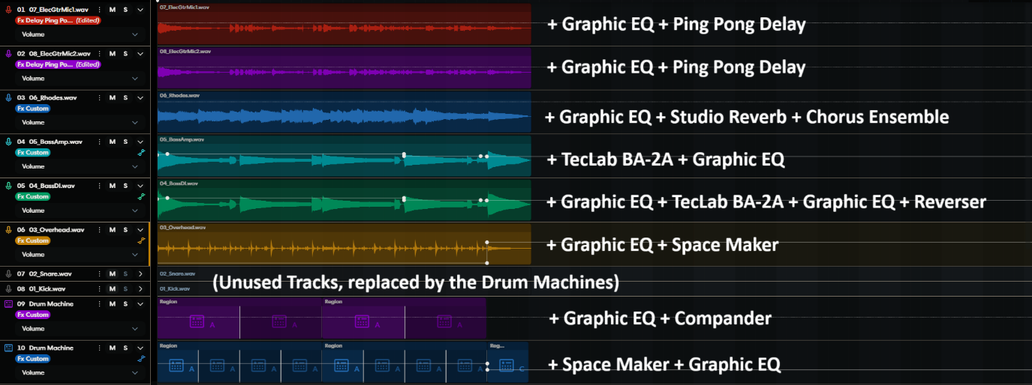

I did not made use of Virtual Instruments since I am terrible at composition – I rather remix existing music. I do not have any instruments so I can’t test out connecting them and trying out most of the features for Virtual Instruments.

**Bugs**

I seem to have found a possible bug where the beat machine would continue playing alone even after I hit Spacebar on my keyboard to stop the playback.

1. Add a new Drum Machine
2. Select any Drum Machine track
3. Ensure every track is active, then start playback on the multitrack by clicking the Play icon
4. Use the Spacebar to pause the multitrack
5. The rest of the track stops but the Drum Machine keeps going
6. Need to press Spacebar again to pause the Drum Machine

I found another unusual behavior which I am not sure if it is a bug.

1. Set up a loop in the seek bar. Don’t enable the loop.
2. Click anywhere beyond the loop on any one track. The white seek goes there and the selected track is highlighted.
3. Press the Start Recording (R) button.
4. After some time, stop the recording.
5. The recording is recorded starting from the start of the position you put the seek to. – This seems like normal behavior to me.
6. Enable the Loop.
7. Repeat Steps 2 – 3
8. Notice that the recording starts from the start of the loop instead of the seek position.

Remarks: Normally if you press the Spacebar to start playback, even with the loop enabled or disabled, it always starts playback from the seek position, rather than the start of the loop.

**Some feedback**

* I am not a fan of the default that showed Beats and Measures. I prefer minutes and seconds since I am better at remembering at the timestamp of each portion of the song rather than remembering the beats and measures.
* I couldn’t drag and drop multiple files into the web version at the same time.
  + Most multi tracks start recording at the same time. I prefer to throw them all in at the same time, so they are perfectly aligned, rather than aligning them myself.
* I found it a bit odd that if you click to select any Drum Machine track, it is automatically solo-ed when you start playback. However, when selecting other tracks, it is NOT solo-ed.
* It was not clear I could create groups with multiple tracks. I held down Shift/Ctrl and clicked each track, but it kept selecting only one track.
  + I then found out that it was in the cascading dot menu of each track that you could create groups (which is a paid feature).
* I wished that the entire automation graph (or part of, in that case, create 2 new automation points) could be shifted vertically at the same time.
* No autosave feature on the web version. I have read that the mobile app has autosave.
* I could not copy plugins over from one track to another. This made it quite troublesome to start with a certain Reverb setting I fine-tuned for track A to copy to track B and tweak it slightly.
* I could not change the vertical zoom. This made automation quite difficult to fine tune.
* I am not used to having the entire track box being movable. Usually, I prefer only the title bar of the track box (the one with the name of the track) to be used to drag the track around. I would rather have the waveform of the track box to allow me to change seek quickly rather than relying on the top seek bar which is quite small.  
  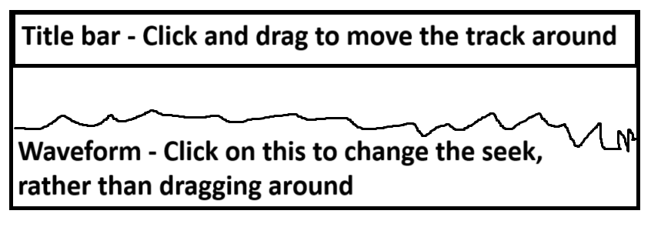
* I struggled to understand how to insert only one beat measure from the Drum Machine. It got confusing for me when in the Drum Machine menu, the “Add A” looked like a button more than a draggable object.  
  
  + I ended up having to use the Overheads track for the final crash (I initially did not want to use it) before finally figuring it out. Therefore, I ended mixing the 2 crashes together. It sounded nice though!
* It would be nice to see the action history (in words), since I may not remember what I did beforehand. A way this could be done is to right click the undo or redo button.
* It would be nice if the Lyrics/Notes screen could allow you to add timestamps by clicking a button to get the current seek to allow easier matching of lyrics.
* The Top Left Hamburger Menu > View > Samples brings up the same menu as BandLab Sounds at the Bottom Right of the web interface, which is strange since the naming convention is not consistent.
* It might be a good idea to have a small VU Meter after every plugin in the chain for the individual tracks. This allows Mixing Engineers to always ensure that after every plugin, unity gain (around 0dB) is maintained. This ensures that every plugin can work properly (Too little input and the next plugin may not have enough detail to apply effects properly. Too much input and distortion may occur, losing detail.) This is illustrated below in Ableton Live.  
  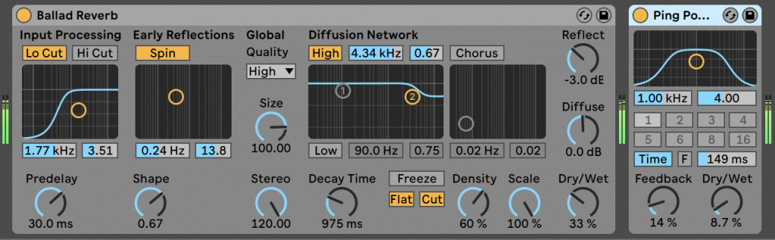
* I noticed that BandLab does not seem to have return tracks, a feature that Ableton Live has.
  + Return tracks are very useful for sending different levels of different tracks to a chain of plugin effects. This is particularly useful when working with reverbs for lead and backup singers.
  + In the example below, the Distort and Drums track send a different level to the Return Track A. Return Track A is labeled “Reverb”, so it will have a Reverb plugin to apply reverb to both tracks to a different extent.  
    A screenshot of a computer

    AI-generated content may be incorrect.
* This may be a slightly specific use case, but it would be nice to have an Automation option that simply enables/disables plugins in the chain.
  + A use case is to change to an entirely different EQ midtrack for a short time.
  + Listen to the track *Life Gets In The Way* by *Fytakyte*. Start playing at around 1:23. At 1:30, the lead vocalist has a radiolike effect, which only lasts for about 4s before changing back to normal.
  + We could have 2 EQ plugins beside each other in the plugin chain. The normal EQ plugin is enabled almost all the time but is disabled during the 4s. The other EQ plugin only enables during those 4s. Otherwise, it is disabled for the rest of the track.

Question 3

In a feature ticket you are working on you notice that one line of acceptance criteria implements a behaviour that is different to a very similar feature we have on a different platform. You also notice that the design document attached to the ticket contradicts some of what is being described in the acceptance criteria. What would you do in this situation?

Answer:

Discuss with my supervisor first. If my supervisor agrees it is out of the ordinary, check with the Project Manager if this acceptance case and the design document are indeed correct.

Update the test cases and test steps if necessary.

Question 4

Login to your BandLab accountant open <https://www.bandlab.com/library/bands> page. Your task:

1. Create a new band using the “+ New” icon
2. What request method was used? Provide the response status code, request-id
3. Attach 2 screenshots with request payload and response data info for the executed Request

Answer:

**The Setup**

To capture the payload and data on iOS, we can use an application called Stream – Network Debug Tool, which is a HTTPS Sniff / Request Replay app.

If we are analyzing unencrypted HTTP traffic, we simply start a packet capture, and every packet sent between the device and the web server is in plain text.

However, to analyze HTTPS traffic [HTTP traffic sent through Transport Layer Security (TLS) encryption], we need to install a certificate in the device. The purpose of this certificate is to allow the device to act as a Man-In-The-Middle (MITM) to decrypt the traffic.

The certificate is generated by the Stream iOS application. We need to download this certificate. On iOS, a pop-up appears to confirm downloading the configuration profile from the Stream app. Once this is done, go to System Settings > General > VPN, DNS & Device Management. The downloaded profile will appear on this page. In my case, the profile is called “Stream Generated CA C930982E”. Install the Profile.

Then go to System Settings > General > About > Certificate Trust Settings. Enable full trust for the root certificate. In my case, it would be “Stream Generated CA C930982E”. This enables the Stream application to be fully trusted through its identity which is represented by its self-signed root certificate.

The same can be done on a PC. The application I used on PC is Burp Suite Community Edition. The concept is the same – We need to install a self-signed certificate generated by Burp Suite Community Edition and give full trust to the self-signed certificate to be used as a root certificate.

**Procedure to gather required information**

We could limit the number of web packets to look through using a whitelist mechanism. Here in the Stream iOS application, I put *.bandlab.com in the whitelist so only traffic to/from bandlab.com are recorded.

We simply click to start sniffing traffic for iOS. For Burp Suite Community Edition, we go to the title bar > Proxy > Intercept > Open browser. This opens a custom Chromium browser where ALL web activity is recorded in Burp Suite.

The below screenshot shows what happens on PC the moment I click on the “+ New” button. We got a request method of **POST**, and a status code of **200** (a standard response for HTTP OK) is returned.

And here is how it looks like on iOS.

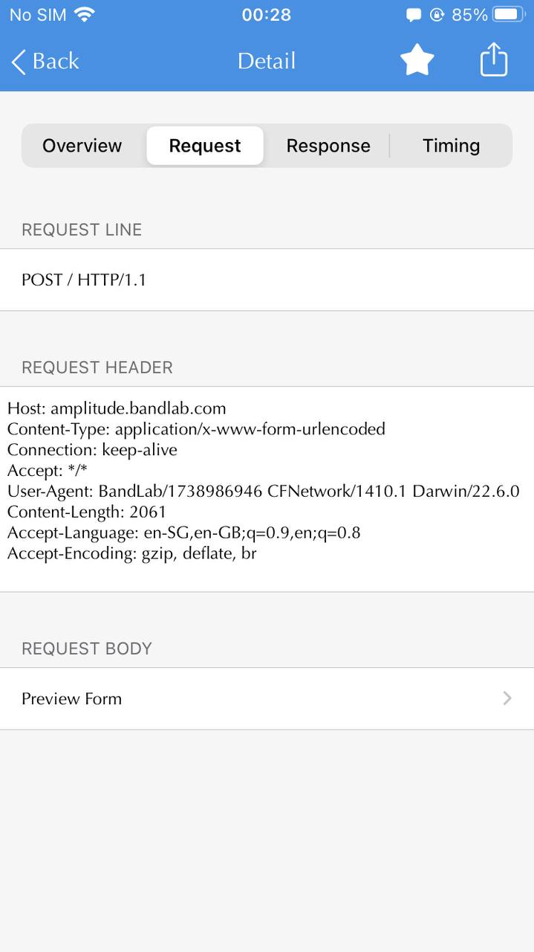 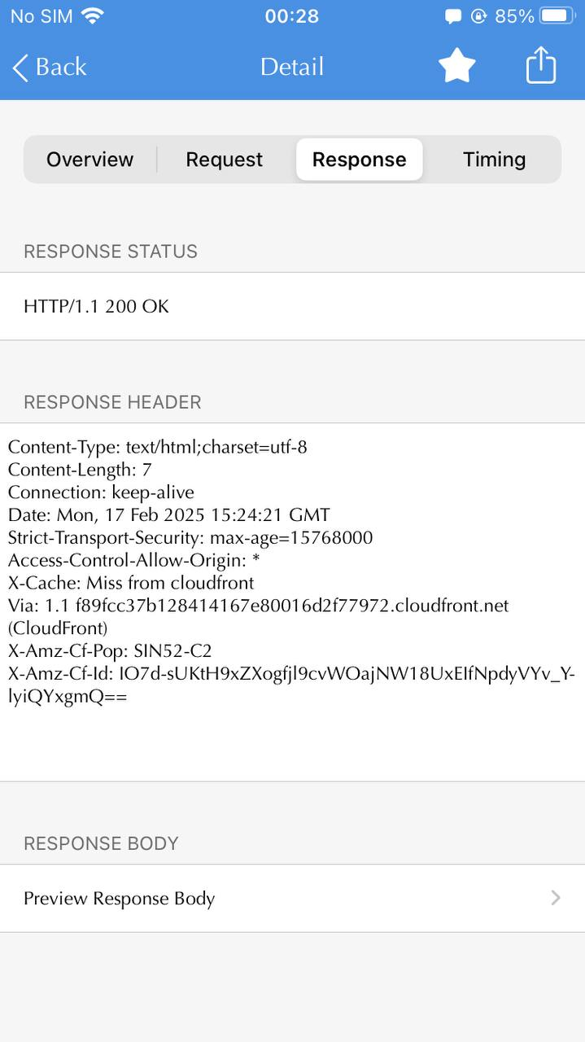

And below shows what happens on PC after I have input a band name and click “Create”. We got a request method of **POST**, a status code of **201** (a standard response for HTTP Created) is returned and we get a X-request-id of **40005c44-1800-2f00-b63f-84710c7967bb** (as highlighted).

And here is how it looks like on iOS. There is a match on the request method of **POST** and the status code of **201** but a different X-request-id of **40004998-5000-8300-b63f-84710c7967bb**.

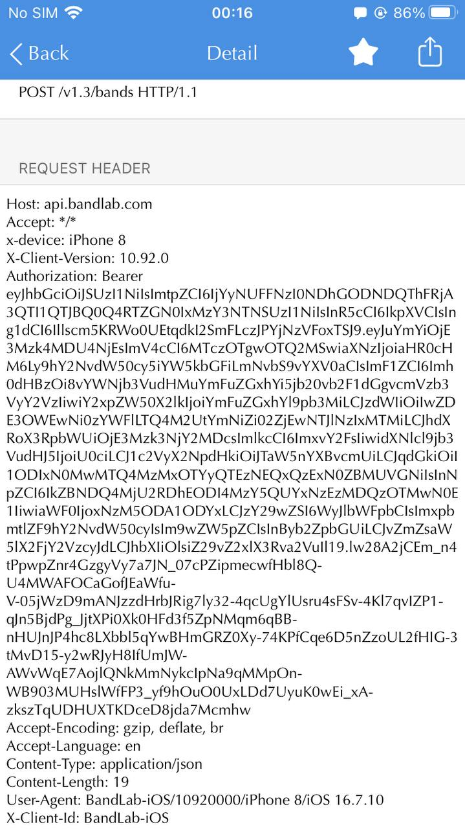

**Extras – Modifying the Response**

Just for fun, I modified the response given from BandLab website back to my browser.

I cheekily changed the image from the default band image to my BandLab profile picture and changed the name of my created band from “ZechTech” to “BandLab!”

Here’s the original response from BandLab website and how the webpage is supposed to be loaded:

Here are the intercept rules I created to cheekily change how the page shows up:

Here is the result:

For iOS, ProxyPin could be used for rewriting the response.

Question 5

Your team is working on implementing DAW automation in BandLab

Automation is a feature that is crucial to music production, and has taken a lot of thought from the product team about how the feature should work in our product.

It interacts with many different parts of the BandLab application and has required a lot of planning from the developers on how they will implement it.

How do you approach testing this from the start of the process to finish? What do you do before, during and after testing this work? What would you test?

Answer:

**Introduction:**

DAW Automation can be fine-tuned to adjust every individual parameter of any plugin.

* The most common DAW Automation is Level Automation, where the volume levels of each track in a multitrack ~~can be~~ are automatically adjusted as the multitrack is played.
* Panning Automation is another popular automation.
  + An example I like to use is *Starjump*, composed for the game *Celeste* by the artist *Lena Raine*. The Panning Automation in *Starjump* was used in a very impactful way to deliver the story for the game *Celeste*.

**Pre-POC:**

There would usually be a Proof-of-Concept (POC) first. This involves using minimum UI or re-used UI to ensure that it works.

The first step is to sit down with the Project Manager to understand what features will be implemented at the POC stage and obtain the list of acceptance cases. Based on this, we can start planning the test cases for this POC. I will submit my first draft to my supervisor for review. Both my supervisor and I can fine tune the test cases.

We can also raise concerns such as possible missing acceptance cases or behavior expectations based on what the Project Manager has presented. In my previous QA experience, the DAW Automation feature would have an Epic ticket. Inside the Epic ticket would contain all the User Story tickets that detail the different acceptance cases.

**POC Testing**

I will propose the development track for DAW Automation, to facilitate the planning of testing from start to finish, based on my knowledge on DAW Automation and testing-oriented methodology. Ultimately, the decision lies with the Project Manager on what features are to be implemented from POC to first beta to Gold Release to possible Phase 2 expansions.

In the context of DAW Automation, let’s say that the POC only has a simple Level Automation. Volume level changes would be an instant jump, making the Level Automation line charts look like square waves. A POC for Level Automation looks extremely scrappy (since the UI/UX designers aren’t involved in the POC stage, so developers would use basic UI from Android Studio or Xcode) and might look something like this:

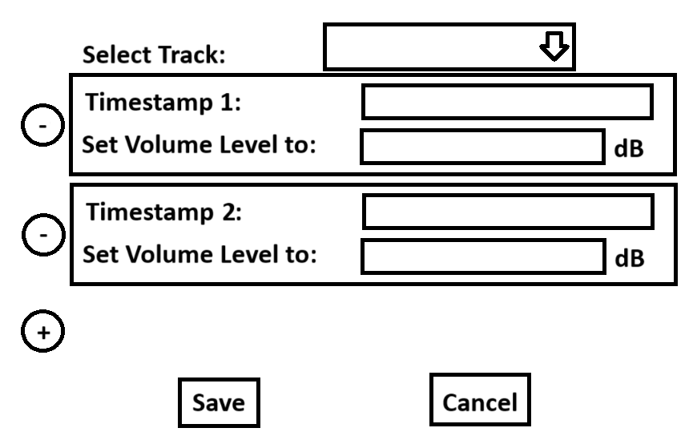

Once the POC is out, I would need to check for instructions on how to install this POC. The installation can be:

* A separate app that requires configuration to link up the main app and the POC feature app. May include needing to manually add a new component to the app.
* A beta version of the main app

**Testing Procedure for the POC**

To test Level Automation,

1. I would set up several timestamps where I would set the volume level significantly higher or lower than the previous timestamp.
2. Solo the track that has Level Automation enabled and listen if there are volume changes.
   * Using Audacity to record the before and after the Level Automation was applied also works.
   * If using Audacity, compare both waveforms to see the difference.
3. I would not be doing stress tests or more advanced tests at the POC stage. This is because the feature may not have been fully integrated into the ecosystem with other components.

**POC test Complete**

After the first POC test is done, there will be a lot of feedback.

* For example, there is a huge flaw in the POC above, which lacked the Global ON/OFF switch for Level Automation, making testing very inconvenient.

I may also have some questions.

* For example, is there a limit as to how many timestamps there can be?
* Will there be automation recording?
* As for feature improvements, while this is a POC, I may ask:
  + What kind of slopes will be offered? Are they just going to be straight line gradients, or would curve lines be offered as well?
  + If a slope is already drawn, can I split the slope into 2?

Depending on the Project Manager’s preference, QA may update on the User Story tickets whether these acceptance criteria are satisfied in the POC. An overall POC test result may also be updated to the Epic ticket. (I did not practice this in my previous QA experience. My Project Manager would create a test ticket for the POC, and we simply would update our test results there without touching any of the User Story or Epic tickets.)

**Moving from POC to First Beta**

After the POC is functional as proven by QA, we move to first beta. At this stage, the UI/UX designer would have a working mock-up of the UI.

The Project Manager would pass the UI mock-up (on Figma, for example) to both the developers and QA. Based on the UI mock-up, we can now start planning even more test cases, particularly UI tests.

Let’s say in the first beta, there is only Level Automation. Instead of discrete jumps in volume levels, users can now add automation points, and a straight-line gradient is automatically generated between 2 automation points. It would look pretty much identical to what BandLab has already implemented, but without the dropdown menu to select automation type and the automation recording.

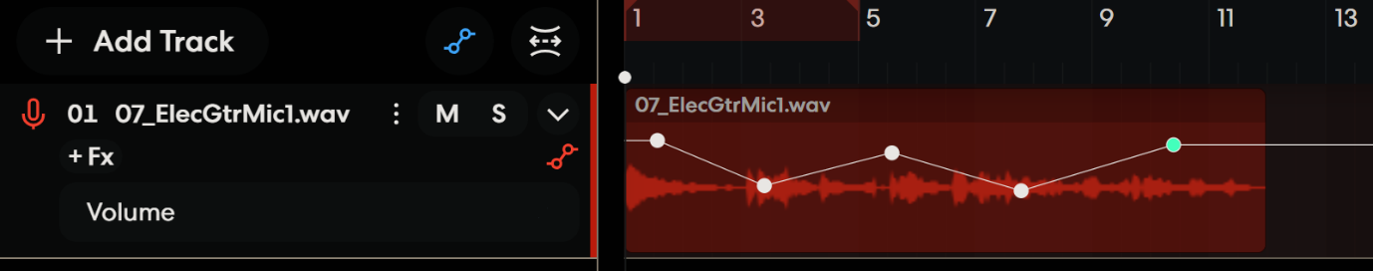

With the feature integrated into the UI, there are significantly more test cases we can test.

* For example, there cannot be gradients sloping backwards since that would result in more than one volume level at some point of the track.

We can start integrating UI test cases and integration tests with existing features.

* For example, what happens if the user tries to adjust the volume level of the track that has volume automation enabled?
  + There are 2 implementations: We either completely disable the adjustment of the volume level or vertically shift the automation line relative to the adjustment.
  + The 2nd implementation comes with issues – what if it was adjusted too high or too low and the volume levels goes above/below the limits?
* We can also start implementing performance tests.
  + This includes CPU usage of the device with automation enabled or running Automations under Low Power Mode (iOS).
  + This also includes drawing rapidly changing volume levels (rapid zigzags) with automation.
* As the implementation becomes more complex, there are more points of failure, such as pops or static with the Automation component interacting with the DSP plugins.

From here on, other features of Automation may be implemented after the first beta has been tested. Like POC testing, it depends on the Project Manager’s preference if the beta test results should be updated to the Epic and User Story tickets, or a test ticket is created for the first beta.

As the beta goes closer to Gold Release, more features may be integrated. Since Automation has the capability to change the parameters of any plugin, the next step could be Panning Automation. Depending on the Project Manager’s preference, Gold Release may or may not include the automation of ALL available parameters in ALL plugins.

* When more automation options are added in later betas, we should definitely test multiple automations running at the same time (A real-world use case, especially with Level Automations) – multiple automations on the same track (e.g. Level + Panning Automation), together with automations on many different tracks.

The beta stage is an iterative cycle until all confirmed features are completed and all reported major bugs are fixed for Gold Release. Each cycle is the same for subsequent beta releases, except test cases will be updated to include new features, with functionality, UI, integration, stress and performance tests.

**Gearing up for Gold Release**

For the final round of testing before Gold Release, the scope of testing may need to be discussed with my supervisor and/or Project Manager to see if it is necessary to test everything, including more complicated integration and performance tests. The final test may simply be a shakedown test or a full stage test, the latter requiring significantly ~~less~~ more time.

If there are showstopper issues during the final test, this will require emergency fixes, which may or may not disrupt testing.

* This is subject to the developers and the Project Manager, who will make the call to see whether fixing the issue will affect testing.
* If it does not affect testing, testing continues, and a cut-in test occurs after the fix is released to QA. (This means previously tested features will NOT be re-tested.)
* If testing needs to be stopped, we will also update in the test results and wait for the fixed version to continue testing. Testing of the fixed version would be also considered cut-in test.

At the end of testing for Gold Release,

* Test results are updated to the Epic ticket.
* User Story tickets are updated with comments from QA. Each acceptance case in each ticket is explicitly addressed.
* Test results are updated to any test ticket created for Gold Release.
* All tickets will be passed back to the Project Manager.

**Moving Forward after Gold Release**

The test cases created during the entire process of implementing DAW Automation would be added to the list of test cases for future releases. As the Automation feature is huge, this might require some discussion with my supervisor or Project Manager about whether the scope of testing should be adjusted, as stage test time is usually limited to a few days. The newly finalized test cases would also be updated to the archive of test cases.

Note that the feature feedback of having curve lines and automation recording were not implemented as part of Gold Release. This could form part of the possible Phase 2 expansion, if the Project Manager agrees to add it in. These features would be added as New User Story tickets to be visited in the future.

**Summary**

Let’s recap with a flowchart:

Question 6

After recording some audio, you add an effect to the recorded track and save. When listening to the saved audio, you no longer hear the effect.

How would you approach this bug? What are your steps to narrow down why this might happen?

Answer:

**Section A – Not a bug?**

First, this may not actually be a bug. It may simply be because the effect is too mild to be heard.

If there is a way to increase the intensity of the effect, I would increase the intensity of the effect and try again.

If the effect has only on and off, and I am unable to hear the effect, I would take both the original track and the track that had the effect applied to it and throw both into Audacity and compare their waveforms.

* For example, I have personally tried Ableton Live’s Plate Reverb that can significantly increase the low frequencies that may be below 20 Hz, which is beyond the human hearing range. Thus, it is probably impossible to hear the effect of the Plate Reverb.

If this still does not work, I would try a different track.

**Section B – It is indeed a bug**

If it is established that the audio effect really does not work, we need to narrow down which component has failed.

I would try an older version of the app to see if any works to adjust the audio effect. If it does, this means the bug only started at a certain version.

* This allows the developers to look through the change in codebase between the last working version and the earliest non-working version.

Check the version of ALL components of the application to see which ones changed between the 2 versions.

* If there’s a Digital Signal Processing (DSP) plugin version change, test tools can be obtained from the developers to apply the audio effects to test only the DSP alone.
  + If the DSP of the latest version works fine, then it is not a DSP issue.
  + If the latest version of the DSP does not work, try different versions of DSPs to establish at which point did the DSP started to fail.
* Similarly, see if there’s a way to replace any UI components with the older version that works without replacing the other components to test.
* Also test if there are any interaction components that could have failed between versions.

Question 7

While working with a Digital Audio Workstation, you notice that your vocals have some static in them after you've finished your recording session. Your recording setup includes a laptop that's running the DAW, an external microphone and headphones.

Your task is to identify the potential causes of this problem and any methods of solving it.

Answer:

There is a huge signal chain where each element needs to be checked one by one.

We start with the easiest and progressively tackle the harder ones. The order of troubleshooting would be:

1. DAW Disable
2. Physical Mic
3. Headphones
4. DAW Mic Effects
5. Audio Driver APO + 3rd party APO Mic Effects
6. Laptop Hardware Circuitry

The easiest is to eliminate the DAW from the equation first. If that doesn’t work, I prefer to check external hardware first because it is easier to swap external hardware than to troubleshoot software.

The laptop’s hardware circuitry is the hardest to diagnose without very specialized tools that only the laptop vendors would have. Thus, it is last to tackle.

Similarly, the Audio Driver APO + 3rd party APO Mic Effects are difficult to diagnose without specialized software tools. However, software tools are easier to obtain rather than sending in the laptop for diagnosis. Thus, it is second last to tackle.

The DAW is less difficult to diagnose since normally, most DSP plugins / APOs from DAWs do not take effect unless the DAW is active.

Throughout this explanation,

* The microphone used in the setup that had the static is called **Mic A**
* The laptop used in the setup is called **Laptop A**
* The headphone in the setup is called **Headphones A**
* A perfect microphone that is verified to not have static is called **Mic B**
* A perfect laptop (that does not have the DAW installed) that is verified to not have static is called **Laptop B**
* A perfect headphone that is verified to not have static is called **Headphones B**
* Before troubleshooting, ensure that Mic B + Laptop B + Headphones B together does not have any static by performing a recording with Mic B and play it back on Headphones B.

**DAW Disable**

Record a new recording with the in-built Sound Recorder program (Windows wise) or Audacity instead of the DAW. The former is preferred because of its simplicity.

* If there is no more static, the cause is established to be the DAW. Refer below to the section on **DAW Mic Effects** for further troubleshooting.
* If there is still static, skip to the next section to troubleshoot further.

**Physical Mic**

1. Make sure the DAW is using Mic A as the recording endpoint.
2. Use Mic A on Laptop B, record something with the in-built Sound Recorder program (Windows wise) or Audacity, and check if there is static in this new recording.
   * If there is static using Mic A on Laptop B, one of the causes of the issue is Mic A.
     1. Connect Mic B to Laptop A.
     2. Test whether there is still static using Headphones B.
        + If there is still static, the static is caused by Mic A and other factors. Skip to the next section to troubleshoot further.
   * If there is no static using Mic A on Laptop B, then the microphone is not the issue. Skip to the next section to troubleshoot further.

**Headphones**

1. Record something with the in-built Sound Recorder program (Windows wise) or Audacity using Laptop B + Mic B.
2. Connect Headphones A to Laptop B.
3. Playback the recording of Mic B on Laptop B on Headphones A
   * If there is static using Headphones A on Laptop B, one of the causes of the issue is Headphones A.
     1. Connect Headphones B to Laptop A.
     2. Test whether there is still static.
        + If there is still static, the static is caused by Headphones A and other factors. Skip to the next section to troubleshoot further.
   * If there is no static using Headphones A on Laptop B, then the headphones is not the issue. Skip to the next section to troubleshoot further.

**DAW Mic Effects**

Note: Since BandLab is a DAW company, I assume that we have the necessary expertise to disable the DAW DSP plugins / APOs.

Using Laptop A, Mic B and Headphones B, record a new recording with the in-built Sound Recorder program (Windows wise) or Audacity instead of the DAW. The former is preferred because of its simplicity.

* If there is still static, the cause of the issue is NOT the DAW. Skip to the next section to troubleshoot further.
* If there is no more static, the cause of the issue is the DAW.
  1. Disable all Mic Effects on the DAW.
  2. Record using Mic B on Laptop A.
  3. Playback the recording on Headphones B.
     + If there is still static even with all Mic Effects disabled, this becomes a difficult problem. As QA, we may lack the expertise from here on.
       - The DAW application itself may contain some Digital Signal Processing (DSP) plugins or even Audio Processing Objects (APOs) that are enabled by default and cannot be disabled through the user interface.
       - Some of these DSP plugins or APOs may be from Dynamic Link Libraries (DLLs) in the case of a Windows operating system.
       - As QA, we may require help from developers to provide us with a way to bypass these DSP plugins to re-test. This requires either:
         * Special developer builds; or
         * Dummy / Stub DSP plugins or APO from developers.
       - Let’s assume that all DSP plugins and APOs can be disabled or bypassed successfully.
     + If there is no more static, enable mic effects one by one to see if which one causes the static.
       - Isolating the effect(s) that caused the static, find out which DSP plugin / APO it relates to.
       - The problem can then be solved by finding a version of the DSP plugin / APO that does not introduce static.

**Audio Driver APO + 3rd party APO Mic Effects**

At this stage, it is likely that the issue lies with the laptop’s software or hardware, since all of DAW, Microphone and Headphones are verified to be working correctly (or have been changed to work correctly)

Many laptops these days (especially Windows laptops) use a combination of Audio Processing Objects (APOs). These APOs apply effects on top of the recording such as Static Noise Suppression, Volume Stabilizer, Acoustic Echo Cancellation (AEC), and many more. They work in the background (usually as a background service) and are always running even though their application may not be running.

* A laptop may use more than one APO chained together. For example, Realtek Audio is installed as the primary audio driver, but 3rd party APOs such as Dolby, Fortmedia or Nahimic are installed on top of Realtek’s APO. Let’s visualize this:  
  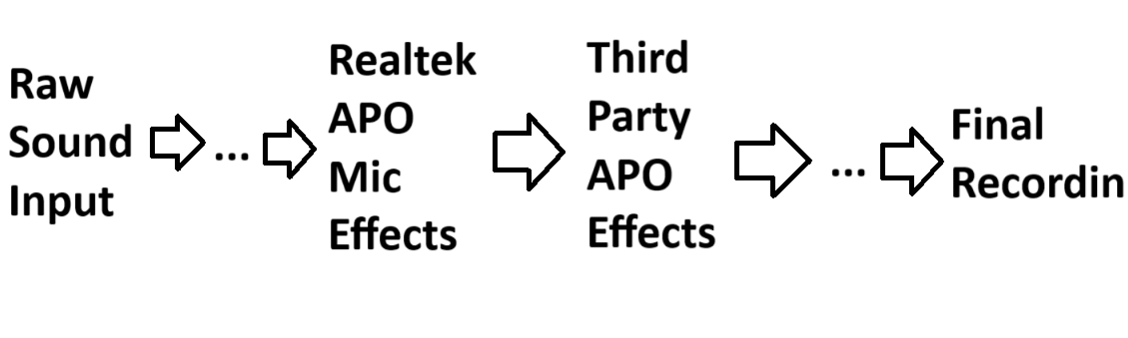
* Sound input is fed into the Realtek’s APO, then passed on to 3rd party’s APO effects.
* These APOs could cause static problems due to bugs.
* The solution would be to try different combinations of disabling the APOs.
  + As each APO is designed by a different vendor, I will not go into the technical details of how.
  + Do a new recording with the in-built Sound Recorder program (Windows wise) or Audacity using Laptop A + Mic B + Headphones B for each combination of disabled APOs.
  + If the recording has no more static, the disabled APO(s) in that combination is/are the problem.
    - If the recording still has static even after disabling all APOs, the APOs are not the cause of the static. Skip to the next section to troubleshoot further.

**Laptop Hardware Circuitry**

If all else fails, it is likely a hardware issue with the laptop itself.

* Try connecting the microphone to another jack if available. Since most laptops only have one microphone analog jack, if the mic used is an analog mic (that uses the device’s Analog jack), use a USB microphone instead. (Make sure the USB Mic doesn’t have static problems)
* If that still doesn’t work, this means the laptop’s circuitry is probably damaged.
  + Since it deals with hardware, it’s impossible for us to continue diagnosing the issue without calling in experts of the laptop’s model.

Question 8

A user has brought up an issue with the application to you, one that you can’t reproduce at all despite several attempts.

What are your next steps?

Answer:

1. Check with the Project Manager if the issue is intermittent.
   * If the issue is intermittent, and is reported to be perhaps 1/20 times, the process should be repeated minimally 2 times the attempts. This means 40 attempts. Check if it can happen even just one time out of the 40.
   * If the issue is not intermittent, repeat the process at least twice.
2. The steps to reproduce the issue may not always be clear.
   * Based on how the issue is reproduced, I would try to think of additional steps in-between.
   * The different combination of steps would become Scenario A, B, and so on.
3. For each scenario, video record the entire process.
   * This can be done using a screen recorder (that also captures the system audio).
     + For Windows, I like to use ShareX.
     + For Android, most devices offer an in-built screen recorder that also records media.
     + For iOS, there is also an in-built recorder through Control Center.
     + If required, a handcam recording can be done, although I prefer to record on an OS level for better clarity.
4. Submit the video evidence to the Project Manager, along with written steps for the entire process for each scenario. Also clearly state the test environment.
5. Allow the Project Manager to check with the user if the steps are accurate.

A few things could happen from here:

* The reported issue is closed or simply put into Keep in View, based on agreement between the Project Manager and the user.
* The user claims to have steps to reproduce. It would fall on the responsibility of the Project Manager to get additional materials from the user to give us QA more information on how to reproduce the issue.
* The issue is hardware specific, and we lack the hardware to reproduce the issue.
  + The user might agree to physically deliver the specific setup that allows us to reproduce the issue.
  + Or the user might request for developer remote support to gather logs and information on the issue.

Question 9

You experience a crash when recording audio.

What do you do from this point forward?

Answer:

1. I have a habit of ALWAYS having a crash dump program running in the background of all my test PCs. I always set the crash dump program to run on system startup, so I never have to bother. This way, I never miss when a crash might occur, which helps a lot with intermittent issues.
   * For PC, ProcDump from Microsoft SysInternal Tools can be used. The following BAT file can be run (the directory of the BAT file must be the same as the ProcDump.exe):  
       
     reg add HKEY_CURRENT_USER\Software\Sysinternals\ProcDump /v EulaAccepted /t REG_DWORD /d 1 /f

cd %SystemRoot%

cd ..

mkdir dumps

cd /d %~dp0

procdump -i C:\dumps

* + For Android, we can use LogCat to retrieve the crashes
    - 1. Enable Developer Mode on the device. This depends from vendor to vendor.
      2. Enable USB Debugging on the device, which is found under Developer Options.
      3. Connect the Android device to a laptop which has Universal Adb driver installed.
      4. Download Android SDK Platform Tools on the laptop.
      5. Start a command prompt inside the folder directory of the Android SDK Platform Tools.
      6. Run the command adb devices. This gets the DeviceID of the Android device.
      7. Run the command adb -s DeviceID logcat -b crash
  + For iOS, we can use in-built Analytics.
    - 1. Go to System Settings.
      2. Privacy & Security > Analytics & Improvements > Analytics Data
      3. All crashes can be found here.

1. Try to recall the steps to reproduce the crash.
2. Try to reproduce it again.
3. Discuss with my supervisor whether it should be logged, if it is a one-off event that cannot be reproduced again.
4. Log a bug ticket with the crash dump attached and the likely / confirmed sequence of steps needed to reproduce the issue.
   * If the issue is intermittent, indicate so in the bug ticket and state the number of occurrences, preferably over at least 20 times.